|  |  |
| --- | --- |
| 1) MySQL runs on which operating systems? | |
| a) Linux and Mac OS-X only | |
| b) Any operating system at all | |
| c) Unix, Linux, Windows and others | |
| d) Unix and Linux only | |
| 2) To remove duplicate rows from the result set of a SELECT use the following keyword: | |
| a) NO DUPLICATE | |
| b) UNIQUE | |
| c) DISTINCT | |
| d) None of the above | |
| 3) Which of the following can add a row to a table? | |
| a) Add | |
| b) Insert | |
| c) Update | |
| d) Alter | |
| 4) To use MySQL on your computer, you'll need? | |
| a) FTP and Telnet | |
| b) Some sort of client program to access the databases | |
| c) A Browser | |
| d) Perl, PHP or Java | |
| 5) Which SQL statement is used to insert a new data in a database? | |
| a) INSERT INTO | |
| b) UPDATE | |
| c) ADD | |
| d) INSERT NEW | |
| 6) In a LIKE clause, you can could ask for any value ending in "qpt" by writing | |
| a) LIKE %qpt | |
| b) LIKE *ton | |
| c) LIKE ton$ | |
| d) LIKE ^.*ton$ | |
| 7) A NULL value is treated as a blank or 0. | |
| a) True | |
| b) Fasle | |
| c) None of the above | |
| 8) MySQL is | |
| a) A Programming language | |
| b) A Programming language | |
| c) A technique for writing reliable programs | |
| d) A Relational Database Management System | |
| 9) In a LIKE clause, you can ask for any 6 letter value by writing? | |
| a) LIKE ?????? | |
| b) LIKE .{6} Answer 5: LIKE ^.{6}$ | |
| c) LIKE (that's six dots) | |
| d) LIKE (that's six underscore characters) | |
| 10) The result of a **SELECT** statement can contain duplicate rows. | |
| a) False | |
| b) True | |
| c) None of the above | |
| 11) Which function used to get the current time in mysql? | |
| a) getTime() | |
| b) Time() | |
| c) NOW() | |
| 12) A table may be joined to itself. | |
| a) True | |
| b) false | |
| c) None of the above | |
| 13) Which of the following is not a valid aggregate function? | |
| a) COUNT | |
| b) MIN | |
| c) MAX | |
| d) COMPUTE | |
| 14) **mysql_pconnect()**  is used to make a persistent connection to the database which means a SQL link that do not close when the execution of your script ends. | |
| a) True | |
| b) False | |
| 15) What SQL clause is used to **restrict the rows** returned by a query? | |
| a) AND | |
| b) WHERE | |
| c) HAVING | |
| d) FROM | |
| 16) Which of the following is used to delete an entire MYSQL database? | |
| a) mysql_drop_database | |
| b) mysql_drop_entiredb | |
| c) mysql_drop_db | |
| d) mysql_drop_dbase | |
| 17) MySQL supports the complete SQL99 standard | |
| a) false | |
| b) true | |
| 18) **Primary Key** does allow the Null Values. where as in  **Unique key** doesn't accept the Null values.  ***Question:***  True or False ? | |
| a) False | |
| b) True | |
| 19)How much character are allowed to create database name? | |
| a) 55 | |
| b) 72 | |
| c) 64 | |
| d) 40 | |
| 20) Which of the following commands should be used to create a database named “student”? | |
| a) CREATE ?I student | |
| b) CREATE DATABASE student | |
| c) DATABASE /student | |
| d) DATABSE student | |
| 21) Which one will delete the table data as well as table structure? | |
| a) TRUNCATE | |
| b) DROP | |
| 22) The USE command? | |
| a) Is used to load code from another file | |
| b) Has been deprecated and should be avoided for security reasons | |
| c) Is a pseudonym for the SELECT command | |
| d) Should be used to choose the database you want to use once you've connected to MySQL | |
| 23) Given an employees table as follows:  emp_id emp_name   1. Brush 2. Jerrin   what value will be return by below query ? Select count(*) from employees | |
| a) 3 | |
| b) 2 | |
| c) 1 | |
| d) none of the above | |
| 24) The main MySQL program that does all the data handling is called? | |
| a) mysql.exe | |
| b) mysql | |
| c) mysqld | |
| d) httpd | |
| 25) A SELECT command without a WHERE clause returns? | |
| a) All the records from a table that match the previous WHERE clause | |
| b) All the records from a table, or information about all the records | |
| c) SELECT is invalid without a WHERE clause | |
| d) Nothing | |
| 26) MySQL Access security is controlled through? | |
| a) The ID that the user logged into the server through, and priveliges set up for that account. | |
| b) MySQL login accounts, and priveliges set for each account | |
| c) The normal login security is sufficient for MySQL, and it does not have any extra controls of its own. | |
| d) A table of valid IP addresses, and priveliges set up for each IP address | |

|  |
| --- |
| 27) In a SELECT with a GROUP BY clause, a WHERE clause, and a HAVING clause, the WHERE conditions are applied before the HAVING conditions. |
| a) True |
| b) Fasle |
| c) Either True or False |
| d) None of the above |

# QUESTION NO: 1

A table is successfully created by executing the following statement:

CREATE TABLE numbers ( double_number double, decimal_number decimal(2,1)

)

One row is successfully inserted into the numbers table. At this point, the table contains the following data:

+ + +

| double_number | decimal_number |

+ + +

| 1.5 | 2.5 |

+ + +

The row is updated by executing the following statement:

UPDATE numbers

SET double_number = double_number + 0.25,

decimal_number = decimal_number + 0.01

Which values are now stored in the double_number and decimal_number columns of the updated row? Select the best response.

**A.** 1.8 and 2.5

**B.** 1.75 and 2.5

**C.** 1.8 and 2.51

**D.** 1.75 and 2.51

# Answer: B QUESTION NO: 2

Which of the following statements can be used to list all databases that are accessible to the current user? Select the best response.

1. LIST DATABASES
2. SHOW DATABASES
3. DISPLAY DATABASES
4. VIEW DATABASES

# Answer: B QUESTION NO: 3

Which of the following statements will discard the existing database called world? Select the best response.

1. DELETE DATABASE world
2. DROP DATABASE world
3. REMOVE DATABASE world
4. TRUNCATE DATABASE world

# Answer: B

**QUESTION NO: 4**

Which statement can be used to list all columns in the City table? Select the best response.

1. DISPLAY COLUMNS FROM City
2. SHOW COLUMNS FROM City
3. SHOW COLUMNS LIKE 'City'
4. SHOW City COLUMNS

# Answer: B

**QUESTION NO: 5**

The default database contains a table called City. Which of the following statements may be executed to obtain a statement that could be used to (re-)create the City table? Select the best response.

1. DESCRIBE City
2. DESCRIBE TABLE City
3. SHOW TABLE City
4. SHOW CREATE TABLE City

# Answer: D

**QUESTION NO: 6**

A MySQL table has ... Select the best response.

1. zero or more columns, and zero or more rows.
2. zero or more columns, and one or more rows.
3. one or more columns, and zero or more rows.
4. one or more columns, and one or more rows.

# Answer: C

**QUESTION NO: 7**

Which part of a SELECT statement specifies the tables from which data is to be retrieved? Select the best response.

**A.** The SELECT list. **B.**

The FROM clause. **C.**

The WHERE clause. **D.**

The LIMIT clause.

# Answer: B

**QUESTION NO: 8**

Which of the following statements best describes the purpose of the SQL WHERE clause? In SQL statements, the WHERE clause specifies ...

Select the best response.

1. the tables from which data is to be retrieved.
2. a condition to filter for only specific rows.
3. a condition to filter for only specific groups defined by a GROUP BY clause.
4. a number to limit the number of rows that is operated upon by the statement.

# Answer: B

**QUESTION NO: 9**

The table Country contains the following rows:

+ + +

| Name | Population |

+ + +

| Nauru | 12000 |

| Turks and Caicos Islands | 17000 |

| Tuvalu | 12000 |

| Wallis and Futuna | 15000 |

+ + +

Which of the following statements will return all rows in the table, sorted by the value in the Population column? Select the best response.

1. SELECT Name, Population ASC FROM Country
2. SELECT Name, ORDER BY Population FROM Country
3. SELECT Name, Population FROM Country

GROUP BY Population ASC

1. SELECT Name, Population FROM CountryORDER BY Population

# Answer: D

**QUESTION NO: 10**

In the context of database transactions, the atomicity property guarantees that... Select the best response.

1. during a transaction, rows are processed one at a time.
2. all statements that are executed inside a transaction are immediately committed.
3. all statements that are executed inside a transaction are committed or rolled back as one unit.
4. other transactions cannot see the changes made in other ongoing uncommitted transactions.

# Answer: C

**QUESTION NO: 11**

The following output describes the table City:

+ + + + + + +

| Field | Type | Null | Key | Default | Extra |

+ + + + + + +

| CountryCode | char(3) | NO | PRI | | |

| CityName | char(35) | NO | PRI | | |

+ + + + + + + The following output describes the table Country:

+ + + + + + +

| Field | Type | Null | Key | Default | Extra |

+ + + + + + +

| CountryCode | char(3) | NO | PRI | | |

| CountryName | char(52) | NO | | | |

| Continent | varchar(10) | YES | | NULL | |

+ + + + + + +

The tables are related through the CountryCode column.

You need to retrieve all cities and list each CityName with the CountryName of only the corresponding country. Is this possible using the following query?

SELECT CityName,CountryName FROM Country

INNER JOIN City

Select the best response.

1. Yes.
2. No, you can't do that in one statement.
3. No, the tables are listed in the wrong order.
4. No, the statement needs a condition to match related rows.

# Answer: D

**QUESTION NO: 12**

Is it possible to save the result of a SELECT statement into a file using an SQL statement? Select the best response.

1. No, not with SQL alone.
2. Yes, by using the FILE() function.
3. Yes, by using the INTO OUTFILE clause.
4. Yes, by using the LOAD DATA INFILE clause.

# Answer: C

**QUESTION NO: 13**

The Country table exists in the default database. In the same database, you need to create a new table called Country_Copy that is to contain the same columns as the Country table, as well as all

of the data in the Country table. Which of the following statements can be used to create the Country_Copy table? Select the best response.

1. CREATE TABLE Country_Copy SELECT * FROM Country
2. INSERT INTO Country_Copy SELECT * FROM Country
3. CREATE TABLE Country_Copy LIKE Country
4. COPY TABLE Country TO Country_Copy

# Answer: A QUESTION NO: 14

The following output describes the table Country:

+ + + + + + +

| Field | Type | Null | Key | Default | Extra |

+ + + + + + +

| Code | char(3) | NO | PRI | | |

| Name | char(53) | NO | | | |

| Population | int(11) | YES | | NULL | |

+ + + + + + +

You want to discard the rows in the Country table for which the value in the Population column is less than 5000 (and retain any other rows). Which of the following statements can be used to do that? Select the best response.

1. DROP Country WHERE Population < 5000
2. DROP FROM Country WHERE Population < 5000
3. DELETE FROM Country WHERE Population < 5000
4. DELETE SELECT * FROM Country WHERE Population < 5000

# Answer: C

**QUESTION NO: 15**

The table Product contains exactly one row:

+ + + +

| Name | Price | Discount |

+ + + +

| bread | 1.00 | NULL |

+ + + +

Which of the options best matches the result returned by the following query: SELECT Price - Price * Discount

FROM Product

Select the best response.

**A.** + +

| Price - Price * Discount |

+ +

| NULL |

+ +

**B.** + +

| Price - Price * Discount |

+ +

| 0 |

+ +

**C.** + +

| Price - Price * Discount |

+ +

| 0.00 |

+ +

**D.** + +

| Price - Price * Discount |

+ +

| 1.00 |

+ +

# Answer: A

**QUESTION NO: 16**

Which of the following statements best describes the meaning of NULL? Select the best response.

1. NULL denotes an empty set. It is used to indicate that a query does not return any rows.
2. NULL denotes the default value for a data type or column.
3. NULL denotes a missing or unknown value.
4. In a string context, NULL is exactly the same as '' - the empty string; in a numerical context, NULL is exactly the same as 0 - zero.

# Answer: C

**QUESTION NO: 17**

You need to create a view called CountryDensity based on the following query: SELECT Code, Name, Population / SurfaceArea As Density

FROM Country

Which of the following statements will create this view? Select the best response.

1. INSERT

INTO CountryDensity

SELECT Code, Name, Population / SurfaceArea As Density FROM Country

1. CREATE TABLE CountryDensity AS

SELECT Code, Name, Population / SurfaceArea As Density FROM Country

1. CREATE VIEW CountryDensity AS

SELECT Code, Name, Population / SurfaceArea As Density FROM Country

1. CREATE CountryDensity AS

SELECT Code, Name, Population / SurfaceArea As Density FROM Country

# Answer: C

**QUESTION NO: 18**

Assuming that the table Country exists, which of the following statements can be used to discard the data and structure of the Country table? Select the best response.

1. TRUNCATE TABLE Country
2. DELETE TABLE Country
3. REMOVE TABLE Country
4. DROP TABLE Country

# Answer: D

**QUESTION NO: 19**

What is the effect of the ROLLBACK statement? Select the best response.

1. Issuing a ROLLBACK statement will undo all changes on transactional tables performed since the beginning of the session.
2. Issuing a ROLLBACK statement will undo all changes on transactional tables performed since the beginning of the transaction.
3. Issuing a ROLLBACK statement will undo all changes made by the previous statement.
4. Issuing a ROLLBACK statement will undo the effect of the previous COMMIT statement.

# Answer: B

**QUESTION NO: 20**

You need to add a char(35) column called LocalName to the existing table City. Which of the following statements may be used to achieve this? Select the best response.

1. CREATE COLUMN LocalName char(35) FOR City
2. INSERT INTO City COLUMNS LocalName char(35)
3. ALTER TABLE City INSERT LocalName char(35)
4. ALTER TABLE City ADD LocalName char(35)

# Answer: D

**QUESTION NO: 21**

Which of the following statements can be used to remove the SurfaceArea column from the Country table? Select the best response.

1. DELETE SurfaceArea FROM Country
2. DROP SurfaceArea FROM Country
3. ALTER TABLE Country DROP SurfaceArea
4. ALTER TABLE Country DELETE SurfaceArea

# Answer: C

**QUESTION NO: 22**

LOAD DATA INFILE ...

Select the best response.

1. is a statement to load data from a text file into a table.
2. is a statement that allows one to recreate an entire database from a text file.
3. is an SQL statement for loading data into a file.
4. loads an SQL script into the mysql command line client.

# Answer: A

**QUESTION NO: 23**

The following output describes the table Country:

+ + + + + + +

| Field | Type | Null | Key | Default | Extra |

+ + + + + + +

| Code | char(3) | | PRI | | |

| Name | char(52) | | | | |

| Population | int(11) | | | 0 | |

| LocalName | char(45) | | | | |

| Capital | int(11) | YES | | NULL | |

+ + + + + + + 5 rows in set (0.00 sec)

The following output describes the table City:

+ + + + + + +

| Field | Type | Null | Key | Default | Extra |

+ + + + + + +

| Id | int(11) | | PRI | NULL | auto_increment |

| Name | char(35) | | | | |

| Country | char(3) | | | | |

+ + + + + + + 3 rows in set (0.00 sec)

The following SQL statements are all syntactically correct, yet one of them will result in an error when executed. Which one? Select the best response.

1. SELECT Name, Name FROM Country

INNER JOIN City

ON Capital = Id

1. SELECT Country, Country FROM Country

INNER JOIN City

ON Capital = Id

1. SELECT Country, Id FROM Country

INNER JOIN City

ON Capital = Id

1. SELECT Country.Name, Id FROM Country

INNER JOIN City

ON Capital = Id

# Answer: A QUESTION NO: 24

After starting a transaction and executing a statement, you accidentally execute ROLLBACK instead of COMMIT. Is there any way to commit the entered statement?

Select the best response.

1. You should execute COMMIT immediately.
2. You should execute CANCEL ROLLBACK and then COMMIT.
3. You should execute REPEAT TRANSACTION and then COMMIT.
4. There is no way to do this. You have to repeat your transaction.

# Answer: D

**QUESTION NO: 25**

The Cities table contains the following rows:

+ + +

| Country | City |

+ + +

| USA | Seattle |

| Germany | Berlin |

| USA | New York |

| Sweden | Stockholm |

+ + +

What will be the result of executing the following query? SELECT Country, City

FROM Cities

ORDER BY Country, City Select the best response.

**A.** + + +

| Country | City |

+ + +

| USA | Seattle |

| Germany | Berlin |

| Sweden | Stockholm |

| USA | New York |

+ + +

**B.** + + +

| Country | City |

+ + +

| Germany | Berlin |

| USA | New York |

| USA | Seattle |

| Sweden | Stockholm |

+ + +

**C.** + + +

| Country | City |

+ + +

| Germany | Berlin |

| Sweden | Stockholm |

| USA | New York |

| USA | Seattle |

+ + +

**D.** + + +

| Country | City |

+ + +

| Germany | Berlin |

| Sweden | Stockholm |

| USA | Seattle |

| USA | New York |

+ + +

# Answer: C

**QUESTION NO: 26**

Assume that the database yellow exists and that no database contains a table called circle. You execute the following statement:

CREATE TABLE yellow.circle(x INT, y INT, r INT)

Which of the following options best describes the effect of executing this CREATE TABLE statement? Select the best response.

1. The table circle is created in the default database.
2. The table yellow.circle is created in the default database.
3. The table circle is created in the database yellow.
4. Executing the statement fails because yellow.circle is not a valid table name.

# Answer: C

**QUESTION NO: 27**

Which result will be returned after executing the following statement? SELECT NULL = NULL

Select the best response.

**A.** + -+

| NULL = NULL |

+ +

| 0 |

+ +

**B.** + +

| NULL = NULL |

+ +

| 1 |

+ +

**C.** + +

| NULL = NULL |

+ +

| TRUE |

+ +

**D.** + +

| NULL = NULL |

+ +

| NULL |

+ +

# Answer: D

**QUESTION NO: 28**

The friends table has the following table structure and data: mysql> SELECT * FROM Friends;

+ + +

| Id | Name |

+ + +

| 1 | Tom |

| 2 | Matt |

| 3 | David |

| 4 | Monty |

+ + +

Which query could be used to retrieve a result similar to the one shown here:

+ +

| Name |

+ +

| Matt |

| Monty |

+ +

Select the best response.

1. SELECT Name FROM Friends

WHERE Id IN ('Matt','Monty')

1. SELECT Name FROM Friends WHERE Name = 'Matt' AND Name = 'Monty'
2. SELECT Name FROM Friends

WHERE Name = 'Matt' OR Name = 'Monty'

1. SELECT Name

FROM Friends matt, Friends monty WHERE matt.name = 'Matt'

AND monty.name = 'Monty'

# Answer: C

**QUESTION NO: 29**

Two rows are inserted into the empty table CountryLanguage:

+ + +

| CountryCode | Language |

+ + +

| NLD | Papiamento |

| NLD | Sranantonga |

+ + +

Is it possible that a single statement was used to insert these rows? Select the best response.

1. Yes, using this statement:

INSERT INTO CountryLanguage (CountryCode,Language) VALUES ('NLD','Papiamento'),

('NLD','Sranantonga')

1. Yes, using this statement:

INSERT INTO CountryLanguage (CountryCode,Language) VALUES ('NLD','Papiamento')

AND ('NLD','Sranantonga')

1. Yes, using this statement:

INSERT INTO CountryLanguage (CountryCode,Language) VALUES ('NLD','Papiamento')

VALUES ('NLD','Sranantonga')

1. No, you need at least two statements, like this:

INSERT INTO CountryLanguage (CountryCode,Language) VALUES ('NLD','Papiamento')

and then

INSERT INTO CountryLanguage (CountryCode,Language) VALUES ('NLD','Sranantonga')

# Answer: A

**QUESTION NO: 30**

How many PRIMARY KEYs can be defined for a given table? Select the best response.

1. At most one PRIMARY KEY may be defined.
2. Exactly one PRIMARY KEY must be defined.
3. At least one PRIMARY KEY must be defined.
4. For each column, at most one PRIMARY KEY may be defined.

# Answer: A

**QUESTION NO: 31**

The following output describes the table City:

+ + + + + + +

| Field | Type | Null | Key | Default | Extra |

+ + + + + + +

| Name | char(35) | NO | PRI | | |

| Population | int(10) unsigned | YES | | NULL | |

| Country | char(35) | NO | PRI | | |

+ + + + + + +

Which of the following statements can be used to add a row for the city called 'Urk' in the country called 'The Netherlands'? Select the best response.

1. INSERT INTO City('Urk',,'The Netherlands')
2. INSERT INTO City VALUES ('Urk','The Netherlands')
3. INSERT INTO City VALUES ('Urk',,'The Netherlands')
4. INSERT INTO City(Name,Country) VALUES ('Urk','The Netherlands')

# Answer: D

**QUESTION NO: 32**

The following output describes the table Country:

+ + + + + + +

| Field | Type | Null | Key | Default | Extra |

+ + + + + + +

| Code | char(3) | | PRI | | |

| Name | char(52) | | | | |

| Capital | int(11) | | | | |

+ + + + + + +

The following output describes the table City:

+ + + + + + +

| Field | Type | Null | Key | Default | Extra |

+ + + + + + +

| Id | int(11) | | PRI | NULL | auto_increment |

| Name | char(35) | | | | |

| Population | int(11) | | | 0 | |

+ + + + + + +

The tables are related: Capital in Country references Id in City. You need to get a list of countries that contains the name of the country as well as the name of the country's capital. Which of the following statements can be used to do that? Select the best response.

1. SELECT Country.Name, Capital.Name FROM Country

**QUESTION NO: 34**

The following output describes the table City:

+ + + + + + +

| Field | Type | Null | Key | Default | Extra |

+ + + + + + +

| id | int(11) | | | 0 | |

| Name | char(35) | YES | | NULL | |

| Population | int(10) | | | 0 | |

+ + + + + + +

Which of the following statements will discard all data in the table without discarding the table structure? Select the best response.

1. DELETE City
2. DELETE FROM City
3. DROP City
4. DROP TABLE City

# Answer: B

**QUESTION NO: 35**

The table keywords contains the following rows:

+ + +

| article_id | keyword + + +

| 1 | Linux |

| 1 | MySQL |

| 1 | Windows |

| 2 | Linux |

| 2 | MySQL |

| 3 | Linux |

| 3 | Windows |

| 4 | MySQL |

+ + +

8 rows in set (0.00 sec)

You want to retrieve all article_id values for those articles that are associated with the keyword

'MySQL' as well as the keyword 'Linux'. Which of the following statements can be used to achieve that? Select the best response.

**C** . FROM keywords AS k1

INNER JOIN keywords AS k2

ON k1.article_id = k2.article_id WHERE k1.keyword = 'MySQL' AND k2.keyword = 'Linux'

**QUESTION NO: 36**

When executing DELETE FROM articles LIMIT 10 Which rows will be deleted? Select the best response.

1. All the rows in the table.
2. The first 10 rows from the table sorted by primary key.
3. The last 10 rows from the table sorted by primary key.
4. The first 10 rows found by the server.

# Answer: D

**QUESTION NO: 37**

In the context of MySQL client/server architecture, the role of the client program is to ... Select the best response.

1. initiate client/server communication.
2. send requests to the server to perform data manipulation.
3. send commands to control server behavior.
4. all of the above.

# Answer: D

**QUESTION NO: 38**

In the context of MySQL client/server architecture, the role of the server program is to ... Select the best response.

1. receive and process commands and queries.
2. send SQL queries to client programs and receive result sets.
3. ensure that only one client may access a piece of data at any one time.
4. all of the above.

# Answer: A

**QUESTION NO: 39**

The City table is created by executing the following statement: CREATE TABLE City ( ID int NOT NULL AUTO_INCREMENT, Name char(35) NOT NULL,

CountryCode char(3) NOT NULL, District char(20), Population int NOT NULL, PRIMARY KEY (ID)

)

Which of the following statements can be used to ensure that no NULL values can be entered for the District column? Select the best response.

1. UPDATE City SET District = NOT NULL
2. UPDATE City MODIFY District NOT NULL
3. ALTER TABLE City SET District NOT NULL
4. ALTER TABLE City CHANGE District District char(20) NOT NULL

# Answer: D

**QUESTION NO: 40**

A database management system is ... Select the best response.

1. a computer hardware component where data is physically stored.
2. a particular kind of computer program that stores and retrieves data on behalf of other applications.
3. a particular kind of computer program that allows end-users to enter SQL statements.
4. a collection of files that stores database data.

# Answer: B

**QUESTION NO: 41**

A VIEW is ...

Select the best response.

1. a temporary table.
2. a special type of query that combines the data from multiple tables.
3. a particular type of table that derives its structure and content from a query.
4. another name for the output obtained by executing a SHOW statement.

# Answer: C Explanation:

**QUESTION NO: 42**

The following output describes the structure of the Product table:

+ + + + + + +

| Field | Type | Null | Key | Default | Extra |

+ + + + + + +

| Name | varchar(32) | NO | | | |

| Price | decimal(5,2) | NO | | | |

| Size | int(11) | YES | | NULL | |

+ + + + + + +

Which of the following queries can be used to find all rows in the Product table for which the Size column contains the NULL value? Select the best response.

**C.**

SELECT *

FROM Product WHERE Size IS NULL

**QUESTION NO: 43**

What is the main reason for adding indexes to tables? Select the best response.

1. Only indexed columns may be used in expressions.
2. Indexes enforce referential integrity.
3. Indexes can speed up execution of queries.
4. Indexes can speed up table maintenance tasks.

# Answer: C Explanation:

**QUESTION NO: 44**

The following output describes the City table:

+ + + + + + +

| Field | Type | Null | Key | Default | Extra |

+ + + + + + +

| Name | char(35) | NO | PRI | | |

| CountryCode | char(3) | NO | PRI | | |

| District | char(20) | YES | | NULL | |

+ + + + + + +

The following statement is used to return all rows in the table: SELECT CountryCode,Name FROM

City

In what order are the rows returned? Select the best response.

1. By CountryCode; then by Name.
2. By Name; then by CountryCode; then by District.
3. No guarantee can be made about the order.
4. The rows are returned in the same order as they were added to the table

# Answer: C

**QUESTION NO: 45**

The following output lists the contents of the City table:

+ + +

| Name | District |

+ + +

| Dallas | Texas |

| New York | New York |

| Chicago | Illinois |

| Los Angeles | California |

| Houston | Texas |

+ + +

Which result will be returned by executing the following statement? SELECT District, Count(District) FROM City

GROUP BY District Select the best response.

**A.** + + +

| District | Count(District) |

+ + +

| California | 1 |

| Illinois | 1 |

| New York | 1 |

| Texas | 1 |

+ + +

**B.** + + +

| District | Count(District) |

+ + +

| California | 1 |

| Illinois | 1 |

| New York | 1 |

| Texas | 2 |

+ + +

**C.** + + +

| District | Count(District) |

+ + +

| California | 1 |

| Illinois | 1 |

| New York | 1 |

| Texas | 1 |

| Texas | 2 |

+ + +

**D.** + + +

| District | Count(District) |

+ + +

| California | 1 |

| Illinois | 1 |

| New York | 1 |

| Texas | 2 |

| Texas | 2 |

+ + +

# Answer: B

**QUESTION NO: 46**

Which of the following activities would imply using a join in a query? Select the best response.

1. Aggregating data from a given table.
2. Making particular groups of the rows in a table.
3. Making a list of all rows from a given table followed by all rows from another table.
4. Making a list of rows that combine data from a given table with data from another table.

# Answer: D

**QUESTION NO: 47**

What is the purpose of the mysqldump program? Select the best response.

1. To migrate a non-MySQL database to a MySQL database.
2. To export MySQL databases to a text file.
3. To make a binary backup of a MySQL database.
4. To convert the binary log into a human readable format.

What is the purpose of the mysqlimport program? Select the best response.

1. To import log files into a MySQL database table.
2. To import data from a binary log into a MySQL database table.
3. To import data from a text file into a MySQL database table.
4. To import tables from a non-MySQL database into a MySQL database.

# Answer: C

**QUESTION NO: 49**

What is the effect of using the keyword LOCAL with the LOAD DATA INFILE statement? Select the best response.

1. With LOCAL, the server will request the file from the client host. Without LOCAL, the server will perform the operation using a file located on the server host.
2. With LOCAL, the server will perform the operation using a file located on the server host. Without LOCAL, the server will request the file from the client host.
3. The keyword LOCAL is optional. The server always performs the operation using a file located on the server host.
4. The keyword LOCAL is optional. The server always requests the file from the client host.

# Answer: A

**QUESTION NO: 50**

Three UPDATE statements have been executed within one transaction. The transaction is still uncommitted when the connection between the server and the client issuing the commands is closed. What will happen to the transaction? Select the best response.

1. All changes are committed.
2. All changes are rolled back.
3. If the connection was closed normally at the clients' request, the changes are committed. If the connection closed abnormally, the changes are rolled back.
4. The changes are neither committed nor rolled back. The entire session state, including the pending changes are saved separately by the server, and the session is restored when the client reconnects.

# Answer: B

# MYSQL Model Test

|  |
| --- |
| 1) To remove duplicate rows from the result set of a SELECT use the following keyword: |
| a) NO DUPLICATE |
| b) UNIQUE |
| c) DISTINCT |
| d) None of the above |

|  |
| --- |
| 2) Which of the following can add a row to a table? |
| a) Add |
| b) Insert |
| c) Update |
| d) Alter |
| 3) Which SQL statement is used to insert a new data in a database? |
| a) INSERT INTO |
| b) UPDATE |
| c) ADD |
| d) INSERT NEW |
| 4) In a LIKE clause, you can could ask for any value ending in "qpt" by writing |
| a) LIKE %qpt |
| b) LIKE *ton |
| c) LIKE ton$ |
| d) LIKE ^.*ton$ |

|  |  |
| --- | --- |
| 5) A NULL value is treated as a blank or 0. | |
| a) True | |
| b) Fasle | |
| c) None of the above | |
| 6) The result of a SELECT statement can contain duplicate rows. | |
| a) False | |
| b) True | |
| 7) A table may be joined to itself. | |
| a) True | |
| b) false | |
| 8) Which of the following is not a valid aggregate function? | |
| a) COUNT | |
| b) MIN | |
| c) MAX | |
| d) COMPUTE | |
| 9) What SQL clause is used to restrict the rows returned by a query? | |
| a) AND | |
| b) WHERE | |
| c) HAVING | |
|  | |
| 10) Primary Key does allow the Null Values. where as in  Unique key doesn't accept the Null values. True or False ? | |
| a) False | |
| b) True | |
| 11) Which of the following commands should be used to create a database named “student”? | |
| a) CREATE student | |
| b) CREATE DATABASE student | |
| c) DATABASE /student | |
| d) DATABSE student | |
| 12) Which one will delete the table data as well as table structure? | |
| a) TRUNCATE | |
| b) DROP | |
| 13) Given an employees table as follows: emp_id emp_name   1. Brush 2. Jerrin   what value will be return by below query ? Select count(*) from employees | |
| a) 3 | |
| b) 2 | |
| c) 1 | |
| d) none of the above | |
| 14) A SELECT command without a WHERE clause returns? | |

|  |
| --- |
| a) All the records from a table that match the previous WHERE clause |
| b) All the records from a table, or information about all the records |
| c) SELECT is invalid without a WHERE clause |
| d) Nothing |

1. Which of the following statements can be used to list all databases that are accessible to the current user? Select the best response.
   1. LIST DATABASES b) SHOW DATABASES
2. DISPLAY DATABASES
3. VIEW DATABASES
4. Which of the following statements will discard the existing database called world? Select the best response.
   1. DELETE DATABASE world b) DROP DATABASE world
5. REMOVE DATABASE world
6. TRUNCATE DATABASE world
7. Which of the following statements best describes the purpose of the SQL WHERE clause? In SQL statements, the WHERE clause specifies ...

Select the best response.

* 1. the tables from which data is to be retrieved.
  2. a condition to filter for only specific rows.
  3. a condition to filter for only specific groups defined by a GROUP BY clause.
  4. a number to limit the number of rows that is operated upon by the statement.

1. The table Country contains the following rows:

+--------------------------+------------+

| Name | Population |

+--------------------------+------------+

| Nauru | 12000 |

| Turks and Caicos Islands | 17000 |

| Tuvalu | 12000 |

| Wallis and Futuna | 15000 |

+--------------------------+------------+

Which of the following statements will return all rows in the table, sorted by the value in the

Population column? Select the best response.

1. SELECT Name, Population ASC FROM Country
2. SELECT Name, ORDER BY Population

FROM Country

1. SELECT Name, Population FROM Country

GROUP BY

Population ASC

1. SELECT

Name, Population FROM

CountryORDER BY Population

1. The following output describes the table Country:

+------------+----------+------+-----+---------+-------+

| Field | Type | Null | Key | Default | Extra |

+------------+----------+------+-----+---------+-------+

| Code | char(3) | NO | PRI | | |

| Name | char(53) | NO | | | |

| Population | int(11) | YES | | NULL | |

+------------+----------+------+-----+---------+-------+

You want to discard the rows in the Country table for which the value in the Population column

is less than 5000 (and retain any other rows). Which of the following statements can be used to do that? Select the best response.

1. DROP Country WHERE Population < 5000
2. DROP FROM Country WHERE Population < 5000
3. DELETE FROM Country WHERE Population < 5000
4. DELETE SELECT * FROM Country WHERE Population < 5000
5. If the table Country exists, which of the following statements can be used to discard the data and structure of the Country table? Select the best response.
6. TRUNCATE TABLE Country
7. DELETE TABLE Country
8. REMOVE TABLE Country
9. DROP TABLE Country
10. You need to add a char(35) column called LocalName to the existing table City. Which of the following statements may be used to achieve this? Select the best response.
11. CREATE COLUMN LocalName char(35) FOR City
12. INSERT INTO City COLUMNS LocalName char(35)
13. ALTER TABLE City INSERT LocalName char(35)
14. ALTER TABLE City ADD LocalName char(35)
15. Which of the following statements can be used to remove the SurfaceArea column from the

Country table? Select the best response.

1. DELETE SurfaceArea FROM Country
2. DROP SurfaceArea FROM Country
3. ALTER TABLE Country DROP SurfaceArea
4. ALTER TABLE Country DELETE SurfaceArea
5. The Cities table contains the following rows:

+---------+-----------+

| Country | City |

+---------+-----------+

| USA | Seattle |

| Germany | Berlin |

| USA | New York |

| Sweden | Stockholm |

+---------+-----------+

What will be the result of executing the following query?

SELECT Country, City

FROM Cities

ORDER BY Country, City Select the best response.

**A.** +---------+ +

| Country | City |

+---------+-----------+

| USA | Seattle |

| Germany | Berlin |

| Sweden | Stockholm |

| USA | New York |

+---------+-----------+

**B.** +---------+ +

| Country | City |

+---------+-----------+

| Germany | Berlin |

| USA | New York |

| USA | Seattle |

| Sweden | Stockholm |

+---------+-----------+

**C.** +---------+ +

| Country | City |

+---------+-----------+

| Germany | Berlin |

| Sweden | Stockholm |

| USA | New York |

| USA | Seattle |

+---------+-----------+

**D.** +---------+ +

| Country | City |

+---------+-----------+

| Germany | Berlin |

| Sweden | Stockholm |

| USA | Seattle |

| USA | New York |

+---------+-----------+

1. The friends table has the following table structure and data: mysql> SELECT * FROM Friends;

+------+-------+

| Id | Name |

+------+-------+

| 1 | Tom |

| 2 | Matt |

| 3 | David |

| 4 | Monty |

+------+-------+

Which query could be used to retrieve a result like the one shown here:

+-------+

| Name |

+-------+

| Matt |

| Monty |

+-------+

Select the best response.

1. SELECT Name FROM Friends

WHERE Id IN ('Matt','Monty')

1. SELECT Name

FROM Friends WHERE

Name = 'Matt' AND

Name = 'Monty'

1. SELECT Name FROM Friends WHERE Name = 'Matt' OR Name = 'Monty'
2. SELECT Name

FROM Friends matt, Friends monty WHERE

matt.name = 'Matt' AND monty.name = 'Monty'

1. Two rows are inserted into the empty table CountryLanguage:

+-------------+-------------+

| CountryCode | Language |

+-------------+-------------+

| NLD | Papiamento |

| NLD | Sranantonga |

+-------------+-------------+

Is it possible that a single statement was used to insert these rows? Select the best response.

1. Yes, using this statement: INSERT INTO CountryLanguage (CountryCode,Language) VALUES ('NLD','Papiamento'),

('NLD','Sranantonga')

1. Yes, using this statement: INSERT INTO CountryLanguage (CountryCode,Language) VALUES

('NLD','Papiamento')

AND ('NLD','Sranantonga')

1. Yes, using this statement:

INSERT INTO CountryLanguage (CountryCode,Language) VALUES ('NLD','Papiamento')

VALUES ('NLD','Sranantonga')

1. No, you need at least two statements, like this: INSERT INTO CountryLanguage (CountryCode,Language) VALUES ('NLD','Papiamento')

and then

INSERT INTO CountryLanguage (CountryCode,Language) VALUES

('NLD','Srananto

nga')

1. How many PRIMARY KEYs can be defined for a given table? Select the best response.
2. At most one PRIMARY KEY may be defined.
3. Exactly one PRIMARY KEY must be defined.
4. At least one PRIMARY KEY must be defined.
5. For each column, at most one PRIMARY KEY may be defined.
6. The following output describes the table City:

+-------------+------------------+------+--

| Field | Type | Null | Key | Default | Extra |

+-------------+------------------+------+--

---+---------+-------+

| Name | char(35) | NO | PRI | | |

| Population | int(10) unsigned | YES | | NULL | |

| Country | char(35) | NO | PRI | | |

+-------------+------------------+------+--

---+---------+-------+

Which of the following statements can be used to add a row for the city called 'Urk' in the country called 'The Netherlands'? Select the best response.

1. INSERT INTO City('Urk',,'The Netherlands')
2. INSERT INTO City VALUES ('Urk','The Netherlands')
3. INSERT INTO City VALUES ('Urk',,'The Netherlands')
4. INSERT INTO City(Name,Country) VALUES ('Urk','The Netherlands')
5. The following output describes the table Country:

+----------------+------------+------+-----+---------+-------+

| Field | Type | Null | Key | Default | Extra |

+----------------+------------+------+-----+---------+-------+

| Code | char(3) | | PRI | | |

| Name | char(52) | | | | |

| Capital | int(11) | | | | |

+----------------+------------+------+---

--+---------+ + The following

output describes the table City:

+------------+----------+------+-----+---------+----------------+

| Field | Type | Null | Key | Default | Extra |

+------------+----------+------+-----+---------+----------------+

| Id | int(11) | | PRI | NULL | auto_increment |

| Name | char(35) | | | | |

| Population | int(11) | | | 0 | |

+------------+----------+------+-----+---------+----------------+

The tables are related: Capital in Country references Id in City. You need to get a list of countries that contains the name of the country as well as the name of the country's capital. Which of the following statements can be used to do that? Select the best response.

1. SELECT Country.Name, Capital FROM Country

INNER JOIN City

ON Capital = City.Id

1. SELECT Country.Name, City.Name

FROM Country INNER JOIN City

1. SELECT Country.Name, City.Name

FROM Country INNER JOIN City

ON Capital = City.Id

1. SELECT Country.Name, Capital.Name FROM Country
2. Given the following tables: mysql> DESCRIBE Country;

+----------------+------------+------+-----+---------+-------+

| Field | Type | Null | Key | Default | Extra |

+----------------+------------+------+-----+---------+-------+

| Code | char(3) | | PRI | | |

| Name | char(52) | | | | |

| Capital | int(11) | YES | | NULL | |

+----------------+------------+------+-----+---------+-------+

mysql> DESCRIBE CountryLanguage;

+------------+---------------+------+-----+---------+-------+

| Field | Type | Null | Key | Default | Extra |

+------------+---------------+------+-----+---------+-------+

| Country | char(3) | | PRI | | |

| Language | char(30) | | PRI | | |

| Percentage | float(3,1) | | | 0.0 | |

+------------+---------------+------+-----+---------+-------+

The tables are related through Code in Country and Country in CountryLanguage. You want to obtain a list with the names of only those countries where English is spoken. Which of the

following queries can be used to obtain sch a list? Select the best response.

1. SELECT Country.Name FROM Country

INNER JOIN

CountryLanguage WHERE

Language = 'English'

1. SELECT

Country.Name FROM Country

INNER JOIN CountryLanguage

ON Country.Code = CountryLanguage.Country WHERE Language = 'English'

1. SELECT Country FROM Country

INNER JOIN CountryLanguage

ON Country.Code = CountryLanguage.Country WHERE Language = 'English'

1. SELECT Country FROM Language

WHERE CountryLanguage = 'English'

1. The following output describes the table City:

+------------+----------+------+-----+---------+-------+

| Field | Type | Null | Key | Default | Extra |

+------------+----------+------+-----+---------+-------+

| id | int(11) | | | 0 | |

| Name | char(35) | YES | | NULL | |

| Population | int(10) | | | 0 | |

+------------+----------+------+-----+---------+-------+

Which of the following statements will discard all data in the table without discarding the table structure? Select the best response.

1. DELETE City
2. DELETE FROM City
3. DROP City
4. DROP TABLE City
5. The table keywords contains the following rows:

+------------+---------+

| article_id | keyword |

+------------+---------+

| 1 | Linux |

| 1 | MySQL |

| 1 | Windows |

| 2 | Linux |

| 2 | MySQL |

| 3 | Linux |

| 3 | Windows |

| 4 | MySQL |

+------------+---------+

8 rows in set (0.00 sec)

You want to retrieve all article_id values for those articles that are associated with the keyword

'MySQL' as well as the keyword 'Linux'. Which of the following statements can be used to achieve that? Select the best response.

1. SELECT DISTINCT article_id FROM keywords

WHERE

keyword = 'MySQL' OR

keyword = 'Linux'

1. SELECT article_id

FROM keywords

WHERE keyword = 'MySQL' AND

keyword = 'Linux'

# C.

SELECT

k2.article_i d FROM

keywords AS k1

INNER JOIN keywords AS k2 ON k1.article_id

= k2.article_id WHERE

k1.keyword = 'MySQL' AND

k2.keyword = 'Linux'

**D.** You cannot do it in a single statement.

1. The City table is created by executing the

following statement: CREATE TABLE City ( ID int NOT NULL

AUTO_INCREMENT,

Name char(35) NOT NULL, CountryCode char(3) NOT NULL,

District char(20),

Population int NOT NULL, PRIMARY KEY (ID)

)

Which of the following statements can be used to ensure that no NULL values can be entered for the District column? Select the best response.

1. UPDATE City SET District = NOT NULL
2. UPDATE City MODIFY District NOT NULL
3. ALTER TABLE City SET District NOT NULL
4. ALTER TABLE City CHANGE District District char(20) NOT NULL
5. The following output describes the City table:

+-------------+------------------+------+-----+---------+-------+

| Field | Type | Null | Key | Default | Extra |

+-------------+------------------+------+-----+---------+-------+

| Name | char(35) | NO | PRI | | |

| CountryCode | char(3) | NO | PRI | | |

| District | char(20) | YES | | NULL | |

+-------------+------------------+------+-----+---------+-------+

The following statement is used to return all

rows in the table: SELECT

CountryCode,Name FROM City In what order are the

rows returned? Select the best response.

1. By CountryCode; then by Name.
2. By Name; then by CountryCode; then by District.
3. No guarantee can be made about the order.
4. The rows are returned in the same order as they were added to the table
5. The following output lists the contents of the City table:

+-------------+------------+

| Name | District |

+-------------+------------+

| Dallas | Texas |

| New York | New York |

| Chicago | Illinois |

| Los Angeles | California |

| Houston | Texas |

+-------------+------------+

Which result will be returned by executing the following statement? SELECT District, Count(District)

FROM City GROUP BY District

Select the best response.

**A.** +------------+ +

| District | Count(District) |

+------------+-----------------+

| California | 1 |

| Illinois | 1 |

| New York | 1 |

| Texas | 1 |

+------------+-----------------+

**B.** +------------+ +

| District | Count(District) |

+------------+-----------------+

| California | 1 |

| Illinois | 1 |

| New York | 1 |

| Texas | 2 |

+------------+-----------------+

**C.** +------------+ +

| District | Count(District) |

+------------+-----------------+

| California | 1 |

| Illinois | 1 |

| New York | 1 |

| Texas | 1 |

| Texas | 2 |

+------------+-----------------+

**D.** +------------+ +

| District | Count(District) |

+------------+-----------------+

| California | 1 |

| Illinois | 1 |

| New York | 1 |

| Texas | 2 |

| Texas | 2 |

1. Which of the following activities would imply using a join in a query? Select the best response.
2. Aggregating data from a given table.
3. Making particular groups of the rows in a table.
4. Making a list of all rows from a given table followed by all rows from another table.
5. Making a list of rows that combine data from a given table with data from another table.
6. Which clause should you use to exclude group results?

A. WHERE B. HAVING

1. RESTRICT
2. GROUP BY
3. ORDER BY
4. You need to calculate the total of all salaries in the accounting department. Which group function should you use?
5. MAX
6. MIN C. SUM

D. COUNT

1. Which clause would you use in a SELECT statement to limit the display to those employees whose salary is greater then 5000?
2. ORDER BY SALARY > 5000
3. GROUP BY SALARY > 5000
4. HAVING SALARY > 5000 D. WHERE SALARY > 5000
5. Which are DML statements? (Choose all that apply)
6. COMMIT…
7. MERGE… C. UPDATE… D. DELETE…
8. CREATE…
9. DROP…
10. Which two statements are true regarding the ORDER BY clause? (Choose two) A. The sort is in ascending by order by default.
11. The sort is in descending order by default.
12. The ORDER BY clause must precede the WHERE clause.
13. The ORDER BY clause is executed on the client side.
14. The ORDER BY clause comes last in the SELECT statement. F. The ORDER BY clause is executed first in the query execution.
15. In a SELECT statement that includes a WHERE clause, where is the GROUP BY clause placed in the SELECT statement?
16. Immediately after the SELECT clause
17. Before the WHERE clause
18. Before the FROM clause
19. After the ORDER BY clause
20. After the WHERE clause
21. The left outer join contains
22. All records of the left table.
23. Only records those match with both tables.
24. All records of the right table.
25. Both left and right records even if they does not match.
26. is a set of programs that enables sorting,

modifying and extracting information from a database.

1. Database
2. Database management system
3. Relational database management system

44. is based on a perception of the world as consisting of a collection of basic objects (entities) and relationships among these objects.

* 1. E-R model
  2. Record based model
  3. Object based model
  4. Relational model

1. is the process of organizing the fields and tables of a relational database to minimize redundancy and dependency.
   1. Redundancy
   2. Consistency c. Normalization
2. normal form should have functional dependency and remove transitive dependencies.
   1. Second
   2. First c. Third

d. Bcnf

1. normal form contains only atomic values, and the value of each attribute contains only a single value from that domain.
   1. Third
   2. First
   3. Second
   4. Bcnf

|  |
| --- |
| 48. In a SELECT with a GROUP BY clause, a WHERE clause, and a HAVING clause, the WHERE conditions are applied before the HAVING conditions. |
| a) True |
| b) Fasle |
| c) Either True or False |
| d) None of the above |

1. What is the effect of the ROLLBACK statement? Select the best response.
2. Issuing a ROLLBACK statement will undo all changes on transactional tables performed since the beginning of the session.
3. Issuing a ROLLBACK statement will undo all changes on transactional tables performed since the beginning of the transaction.
4. Issuing a ROLLBACK statement will undo all changes made by the previous statement.
5. Issuing a ROLLBACK statement will undo the effect of the previous COMMIT statement.
6. After starting a transaction and executing a statement, you accidentally execute

ROLLBACK instead of COMMIT. Is there any way to commit the entered statement? Select the best response.

1. You should execute COMMIT immediately.
2. You should execute CANCEL ROLLBACK and then COMMIT.
3. You should execute REPEAT TRANSACTION and then COMMIT.
4. There is no way to do this. You have to repeat your transaction.

# 1 . The wildcard in a WHERE clause is useful when?

# An exact match is necessary in a SELECT statement.

# An exact match is not possible in a SELECT statement.

# An exact match is necessary in a CREATE statement.

# An exact match is not possible in a CREATE statement.

# Answer: B

# A table that displays data redundancies yields ________ anomalies

# Insertion

# Deletion

# Update

# All of the above

# Answer: All of the above

# If there is more than one key for relation schema in DBMS then each key in relation schema is classified as

# Prime key

# Super key

# Candidate key

# Primary key

# Answer: Candidate key

# A view is which of the following?

# A virtual table that can be accessed via SQL commands

# A virtual table that cannot be accessed via SQL commands

# A base table that can be accessed via SQL commands

# A base table that cannot be accessed via SQL commands

# Answer: A

# Which of the following are the five built-in functions provided by SQL?

# COUNT, SUM, AVG, MAX, MIN

# SUM, AVG, MIN, MAX, MULT

# SUM, AVG, MULT, DIV, MIN

# SUM, AVG, MIN, MAX, NAME

# Answer: A

# The HAVING clause does which of the following?

# Acts like a WHERE clause but is used for groups rather than rows.

# Acts like a WHERE clause but is used for rows rather than columns.

# Acts like a WHERE clause but is used for columns rather than groups.

# Acts EXACTLY like a WHERE clause.

# Answer: A

# Find the SQL statement below that is equal to the following: SELECT NAME FROM CUSTOMER WHERE STATE = 'VA';

# SELECT NAME IN CUSTOMER WHERE STATE IN ('VA');

# SELECT NAME IN CUSTOMER WHERE STATE = 'VA';

# SELECT NAME IN CUSTOMER WHERE STATE = 'V';

# SELECT NAME FROM CUSTOMER WHERE STATE IN ('VA');

# Answer: D

# Which join refers to join records from the write table that have no matching key in the left table are include in the result set:

# Left outer join

# Full outer join

# Right outer join

# Half outer join

# Answer: Right outer join

# A _____ is a property of the entire relation, rather than of the individual tuples in which each tuple is unique.

# Rows

# Key

# Attribute

# Fields

# Answer: key

# Which of the following statements creates a new table temp instructor that has the same schema as instructor.

# create table temp_instructor;

# Create table temp_instructor like instructor;

# Create Table as temp_instructor;

# Create table like temp_instructor;

# Answer: B

# Captionless Image1,0

# 1,2

# 1,3

# 1,5

# Answer: 1,3

# C

# User() function return the current user name and

# both a and b above

# database name associated with the use

# host name

# Password

# Answer: host name

# Screen Clipping3

# 9

# 5

# 6 Answer: 5

# Screen Clipping

# Find the names of all suppliers who have supplied a non-blue part.

# Find the names of all suppliers who have not supplied a non-blue part.

# Find the names of all suppliers who have supplied only blue parts.

# Find the names of all suppliers who have not supplied only blue parts.

# None

# Answer: D who have not supplied only blue parts

# Screen Clipping

# select R.* from R, S where R.a=S.a (D)

# select distinct R.* from R,S where R.a=S.a

# select R.* from R,(select distinct a from S) as S1 where R.a=S1.a

# select R.* from R,S where R.a=S.a and is unique R

# Answer: C

# Screen Clipping

# Answer: D

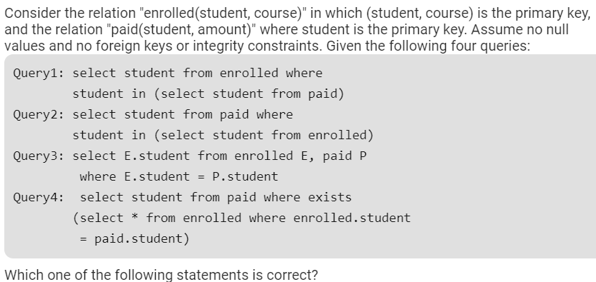 All queries return identical row sets for any database

Query2 and Query4 return identical row sets for all databases but there exist databases for which Query1 and Query2 return different row sets.

There exist databases for which Query3 returns strictly fewer rows than Query2

There exist databases for which Query4 will encounter an integrity violation at runtime.

Answer: B

* **The data type BLOB stands for:**
  + Binary Large Object
  + Big List Object
  + Binary List Object
  + None of the above

Answer: A

* **The student marks should not be greater than 100. This is**
  + Integrity constraint
  + Referential constraint
  + Over-defined constraint
  + Feasible constraint

Answer: Integrity constraint

* **Which of the following statements is NOT true for views in SQL?**
  + Select statement used in the view definition cannot include ORDER BY clause.
  + A view drives its data from the base tables(s)
  + A view is updatable if it has been defined from a single relation
  + A view contains a copy of the data

Answer: A

* **_____ is process of extracting previously non known valid and actionable information from large data to make crucial business and strategic decisions.**
  + Data Management
  + Database
  + Data Mining
  + Meta Data

Answer: Data mining

* **Which of the following is true?**
  + A relation in BCNF is always in 3NF.
  + A relation in 3NF is always in BCNF.
  + BCNF and 3NF are same.
  + A relation in BCNF is not in 3NF

Answer: A

* **Data Warehouse provides**
  + Transaction Responsiveness
  + Demand and Supply Responsiveness
  + Storage, Functionality Responsiveness to queries
  + None of the above

Answer: C

* **What will be the output of this query UPDATE tab_name SET col1 = col1 + 1, col2 = col1;**
  + col1 and col2 have different value
  + col1 and col2 have same value
  + col2 has original value of col1
  + None of the above

Answer: B

* In which of the following is a single-entity instance of one type related to many entity instances of another type?
  + One-to-One Relationship
  + One-to-Many Relationship
  + Many-to-Many Relationship
  + Composite Relationship

Answer: B

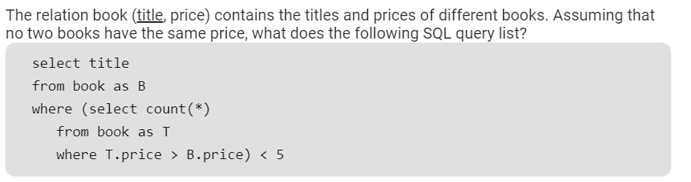

Titles of the four most expensive books

Title of the fifth most inexpensive book

Title of the fifth most expensive bookTitles of the five most expensive books

Titles of the five most expensive books

Answer: D



Titles of the four most expensive books

Title of the fifth most inexpensive book

Title of the fifth most expensive bookTitles of the five most expensive books

Titles of the five most expensive books

Answer: D

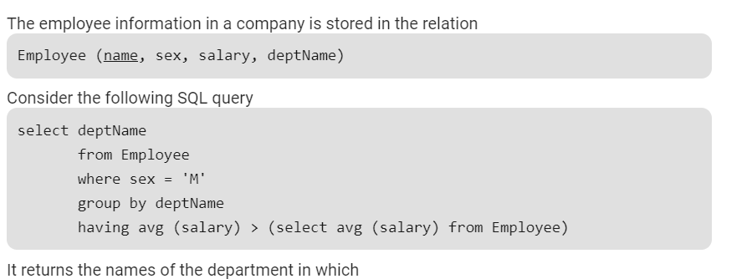

the average salary is more than the average salary in the company

the average salary of male employees is more than the average salary of all male employees in the company

the average salary of male employees is more than the average salary of employees in the same department

the average salary of male employees is more than the average salary in the company

Answer: D

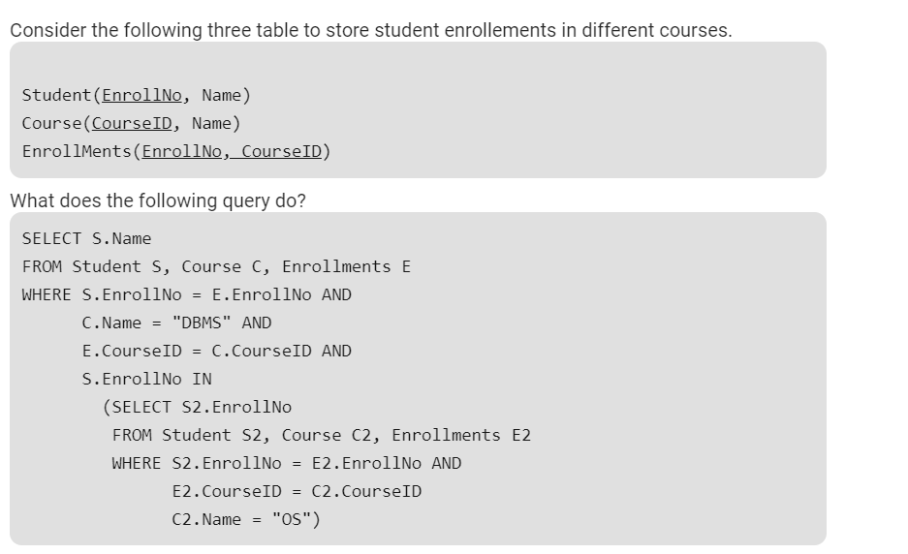

Name of all students who are either enrolled in "DBMS" or "OS" courses

Name of all students who are enrolled in "DBMS" and "OS“

Name of all students who are either enrolled in "DBMS" or "OS" or both.

None of the above

Answer: B

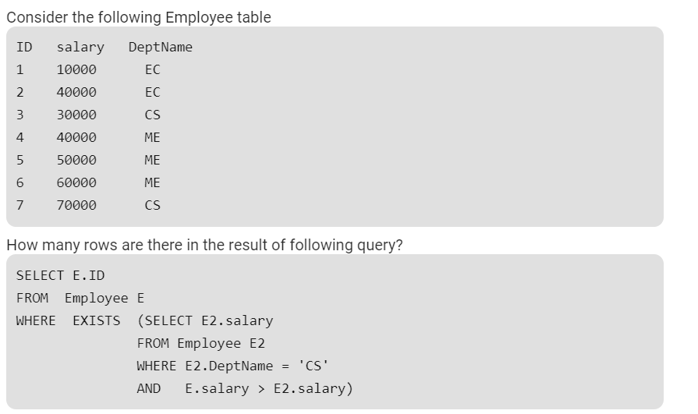

0

4

5

6

Answer: 5

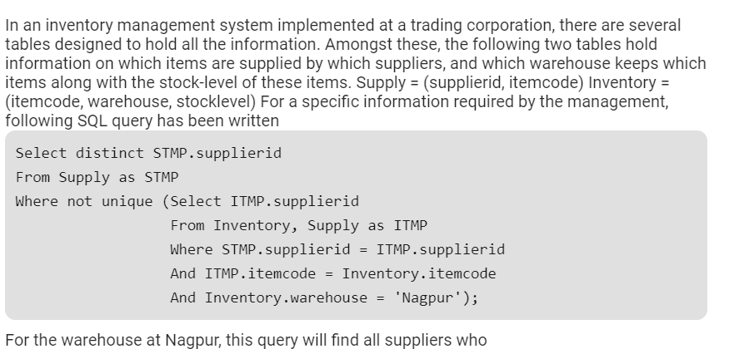

do not supply any item

supply exactly one item

supply one or more items

supply two or more items

Answer: D